Question 1: What is a variable in C/C++?
* Problem Statement
A variable is a named memory location used to store data that can change during program execution.
Every variable has: a Name (identifier), a Data Type, and a Value.
* Algorithm
1. Declare a variable with a data type and name.
2. Assign a value to it.
3. display the variable.
* Dry Run
int age = 20;-> Memory is allocated for 'age' (4 bytes)-> Value 20 is stored at that location-> age = 20
*C++ Code
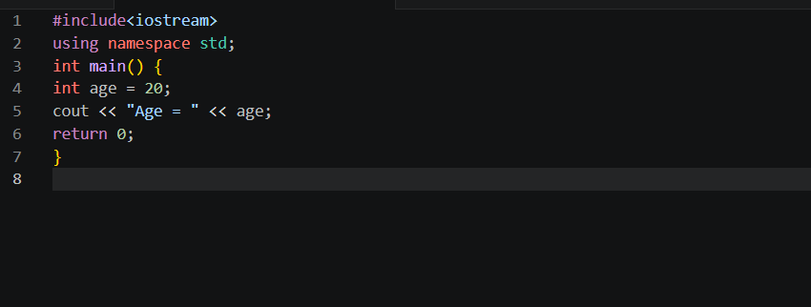
*Output
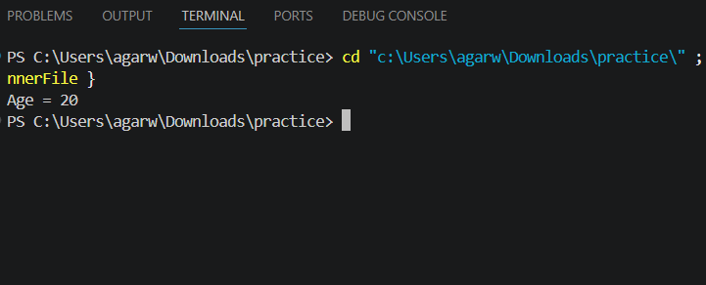
*Explanation of Logic
The compiler allocates memory for 'age', stores the value 20 in it, and cout displays it.

Question 2: Why do we use variables in programs?
*Problem Statement
Explain the purpose of variables — why programs need them to function properly.
*Algorithm / Steps
1. Identify what data the program needs to store.
2. Declare variables to hold that data.
3. Use variables to process and display results.
*Dry Run
int a = 5, b = 10, sum;
sum = a + b;-> sum = 5 + 10 = 15
*C++ Code
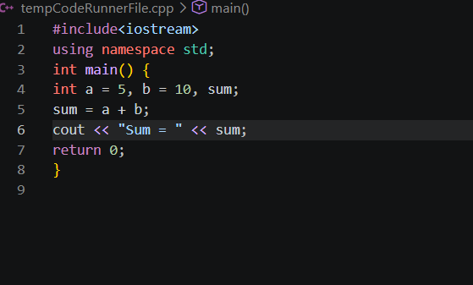
*Output
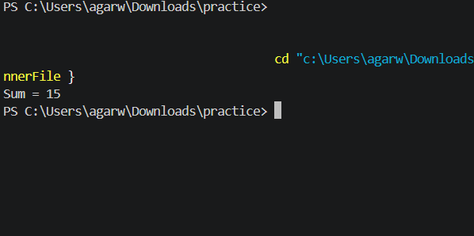
*Explanation of Logic
Without variables, we cannot store input, intermediate values, or results. Variables make programs
dynamic and reusable.

Question 3: Difference between a variable name and its value
*Problem Statement
Distinguish between the identifier (name) of a variable and the data (value) it holds.
*Algorithm / Steps
1. Declare variable: int marks = 95;
2. 'marks' is the variable NAME.
3. 95 is the VALUE stored in it.
4. Display both to show the difference.
*Dry Run
int marks = 95;
Variable Name : marks (label used in code)
Variable Value : 95 (data stored in memory)
*C++ Code
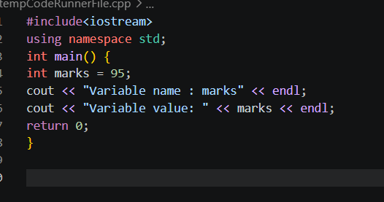
*Output
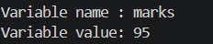
*Explanation of Logic
The name is what we write in code to refer to the memory location; the value is the actual data stored
there. Changing the value does not change the name.

Question 4: Which is a valid variable name?
*Problem Statement
From: a) 2num b) total_marks c) for d) my marks — identify the valid variable name.
*Algorithm / Steps
Rules for valid variable names:
1. Must start with a letter or underscore.
2. Cannot be a keyword.
3. Cannot contain spaces.
4. Can contain letters, digits, underscores.
*Dry Run
2num -> INVALID (starts with digit)
total_marks -> VALID
for -> INVALID (keyword)
my marks -> INVALID (has space)
Answer: b) total_marks
*C++ Code
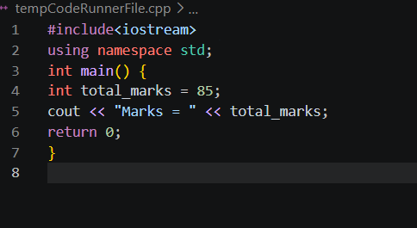
*Output

*Explanation of Logic
Only 'total_marks' satisfies all naming rules: starts with a letter, uses only letters and underscore, and is
not a reserved keyword.

Question 5: Why is Age different from age?
*Problem Statement
Demonstrate that C++ is case-sensitive, so 'Age' and 'age' are two different identifiers.
*Algorithm / Steps
1. Declare two variables: 'Age' and 'age'.
2. Assign different values.
3. Display both to prove they are distinct.
*Dry Run
int Age = 25;
int age = 18;-> 'Age' and 'age' occupy different memory locations
-> They are completely separate variables
*C++ Code
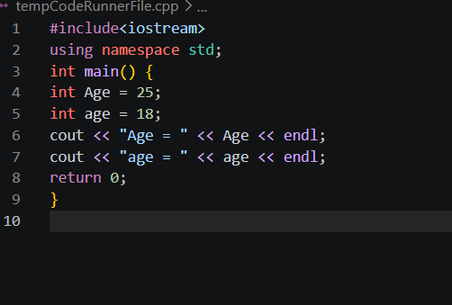
*Output
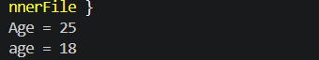
*Explanation of Logic
C++ is case-sensitive. The compiler treats uppercase and lowercase letters as distinct characters, so 'Age'
and 'age' are entirely separate variables.

Question 6: Can a variable name contain spaces? Why?
*Problem Statement
Determine whether spaces are allowed in variable names and explain the reason.
*Algorithm / Steps
1. Understand that the compiler tokenises source code by whitespace.
2. A space inside a name would split it into two tokens.
3. This causes a syntax/compilation error.
*Dry Run
int my marks = 50; // ERROR: treated as 'int my' then 'marks = 50'
int myMarks = 50; // VALID
*C++ Code
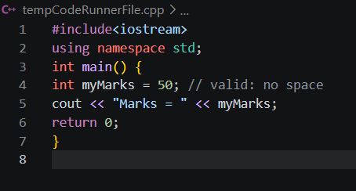
*Output
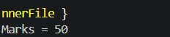
*Explanation of Logic
Spaces separate tokens in C++. A name with a space would be parsed as two separate identifiers,
causing a compile-time error. Use camelCase or underscores instead.

Question 7: Can a variable name start with an underscore?
*Problem Statement
Check whether an underscore (_) is a legal first character for a variable name in C++.
*Algorithm / Steps
1. Recall: variable names may start with a letter OR underscore.
2. Declare a variable starting with _.
3. Verify it compiles and works correctly.
*Dry Run
int _count = 10;-> '_count' starts with underscore -> VALID-> Memory allocated, value 10 stored
*C++ Code
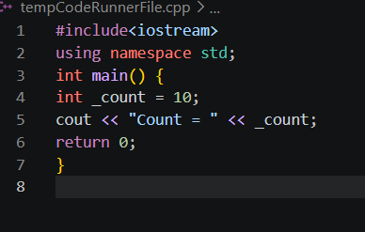
*Output
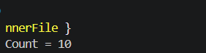
*Explanation of Logic
Underscores are allowed as the first character. However, names starting with __ (double underscore) or _
followed by an uppercase letter are reserved by the compiler and should be avoided.

Question 8: What happens if two variables have the same name in the same scope?

*problem Statement
Describe the outcome when two variables with identical names are declared in the same scope.
*Algorithm / Steps
1. Declare a variable 'x'.
2. Attempt to declare 'x' again in the same scope.
3. Compiler detects redeclaration -> error.
*Dry Run
int x = 5;
int x = 10; // Compiler error: 'x' was already declared in this scope
*C++ Code
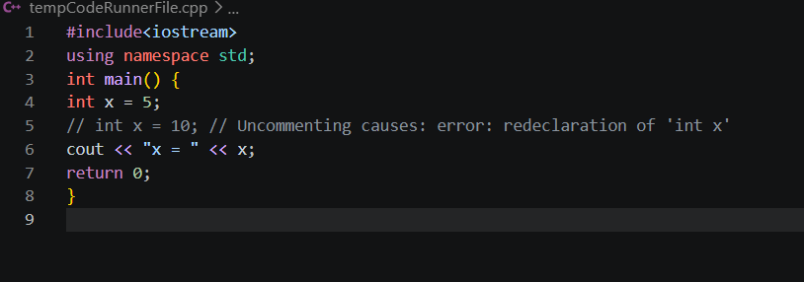
*Output
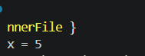
*Explanation of Logic
C++ does not allow two variables with the same name in the same scope. The compiler raises a
'redeclaration' error. Use different names or different scopes (blocks) to avoid this.

Question 9: Write three meaningful variable names for storing student
information
*Problem Statement
Create and use three descriptive variable names relevant to student data.
*Algorithm / Steps
1. Identify data to store: name, roll number, marks.
2. Choose clear, meaningful identifiers.
3. Declare, assign, and display them.
*Dry Run
studentName -> stores text "Alice"
rollNumber -> stores integer 101
totalMarks -> stores integer 92
*C++ Code
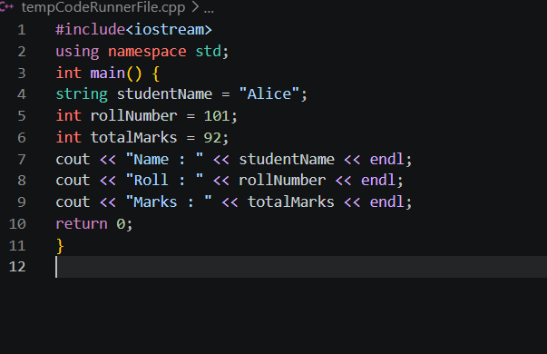
*Output
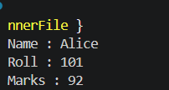
*Explanation of Logic
Meaningful names (studentName, rollNumber, totalMarks) make code self-documenting. Anyone reading
the code immediately understands what each variable stores.

Question 10: Which is better: studentMarks or sm?
*Problem Statement
Compare two naming styles and justify which is preferable for professional code.
*Algorithm / Steps
1. 'sm' is short but cryptic.
2. 'studentMarks' is descriptive (camelCase).
3. Readability and maintainability favour descriptive names.
*Dry Run
int sm = 85; // unclear: what is sm?
int studentMarks = 85; // clear: stores student marks
*C++ Code
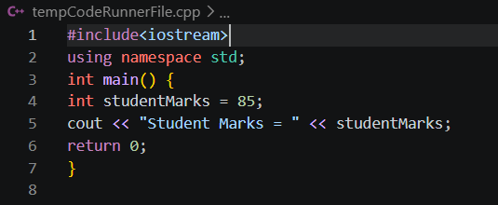
*Output
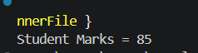
*Explanation of Logic
'studentMarks' follows camelCase convention and is self-explanatory. 'sm' saves a few keystrokes but
hurts readability and maintenance, especially in large programs.

Question 11: What is a data type?
*Problem Statement
Define data type and demonstrate common C++ data types with examples.
*Algorithm / Steps
1. A data type specifies what kind of value a variable holds.
2. It also determines memory size.
3. Common types: int, float, char, bool, string.
*Dry Run
int -> 4 bytes, whole numbers
float -> 4 bytes, decimals
char -> 1 byte, single character
bool -> 1 byte, true/false
*C++ Code
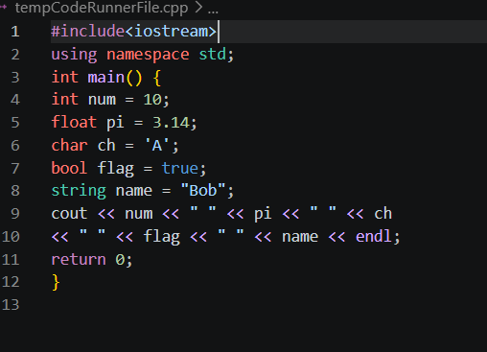
*Output
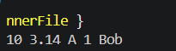
*Explanation of Logic
Data types tell the compiler how much memory to allocate and how to interpret the stored bits. Choosing
the right data type avoids wasted memory and incorrect results.

Question 12: Which data type stores whole numbers?
*Problem Statement
Identify and demonstrate the data type used for integer (whole number) values.
*Algorithm / Steps
1. Use 'int' for whole numbers.
2. Declare an int variable.
3. Assign and display a whole number.
*Dry Run
int count = 50;-> 4 bytes allocated-> Value 50 stored (no decimal part)
*C++ Code
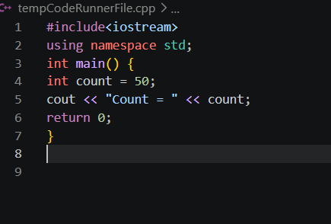
*Output
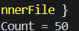
*Explanation of Logic
'int' (integer) is the standard data type for whole numbers in C++. It occupies 4 bytes and can store values
from approximately -2 billion to +2 billion.

Question 13: Which data type stores decimal values?
*Problem Statement
Identify and demonstrate the data type(s) used for numbers with decimal points.
*Algorithm / Steps
1. Use 'float' for single-precision decimals.
2. Use 'double' for higher precision.
3. Declare, assign, and display.
*Dry Run
float price = 9.99; -> 4 bytes, ~6-7 digits precision
double pi = 3.14159; -> 8 bytes, ~15 digits precision
*C++ Code
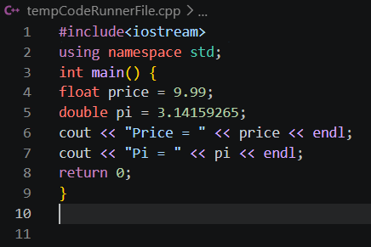
*Output
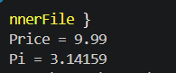
Explanation of Logic
'float' and 'double' store decimal (floating-point) numbers. Use float for lower precision needs and double
when more decimal accuracy is required.

Question 14: What is the difference between float and double?
*Problem Statement
Compare float and double data types in terms of size and precision.
*Algorithm / Steps
1. float -> 4 bytes, ~6-7 significant digits.
2. double -> 8 bytes, ~15-16 significant digits.
3. Use double when higher accuracy is needed.
*Dry Run
float f = 3.14159265358979; -> stored as ~3.14159
double d = 3.14159265358979; -> stored as ~3.14159265359
*C++ Code
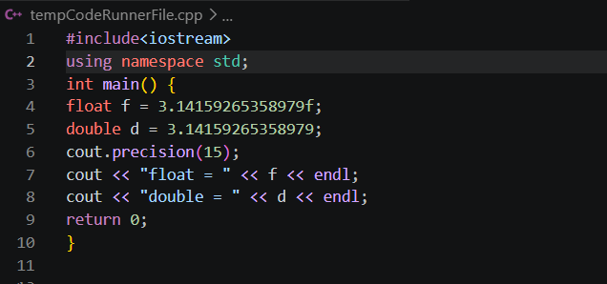
* Output
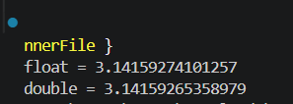
*Explanation of Logic
float uses 4 bytes giving ~6-7 digits of precision; double uses 8 bytes giving ~15-16 digits. For scientific
calculations, double is preferred to avoid rounding errors.

Question 15: Which data type stores a single character?
*Problem Statement
Identify and use the data type for storing a single character in C++.
*Algorithm / Steps
1. Use 'char' for single characters.
2. Enclose the character in single quotes.
3. Declare, assign, and display.
*Dry Run
char grade = 'A';-> 1 byte allocated-> ASCII value of 'A' (65) stored
*C++ Code
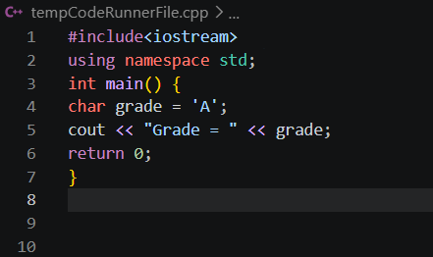
*Output
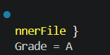
*Explanation of Logic
'char' stores a single character using its ASCII numeric code. It occupies 1 byte. Character literals are
written in single quotes, e.g., 'A', 'z', '5'.

Question 16: Which data type stores True/False values?
*Problem Statement
Identify and demonstrate the boolean data type in C++.
*Algorithm / Steps
1. Use 'bool' for true/false values.
2. 'true' is stored as 1, 'false' as 0.
3. Declare, assign, and display.
*Dry Run
bool isPassed = true;-> 1 byte allocated-> Value 1 (true) stored
*C++ Code
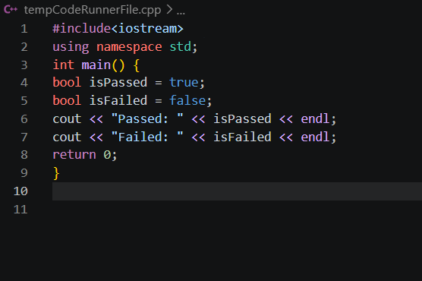
*Output
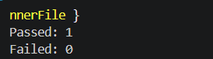
*Explanation of Logic
'bool' (boolean) stores only two values: true (1) or false (0). It is used in conditions and logical operations.
cout displays 1 for true and 0 for false by default.

Question 17: What data type is suitable for storing a person's name?
*Problem Statement
Determine the correct data type for storing a full name (sequence of characters) in C++.
*Algorithm / Steps
1. A name is multiple characters -> use string.
2. Include the header.
3. Declare, assign, and display.
*Dry Run
string name = "Alice";
-> Stores sequence: A-l-i-c-e-> char would only hold one character
*C++ Code
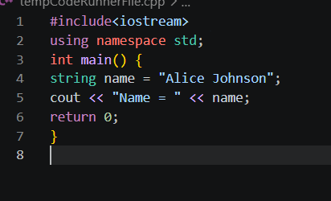
*Output
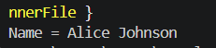
*Explanation of Logic
'string' is used for text (sequences of characters). A single char can only hold one character. string is part
of the C++ Standard Library and requires #include<iostream>.

Question 18: Predict the output: int age=18; cout<<age;
*Problem Statement
Trace and predict the output of a simple variable declaration and output statement.
*Algorithm / Steps
1. int age = 18; -> declares integer variable, stores 18.
2. cout << age; -> prints the value of age to screen.
*Dry Run
int age = 18;
cout << age;-> age holds 18-> Output: 18
*C++ Code
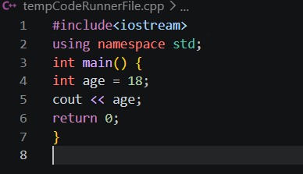
*Output
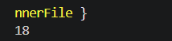
*Explanation of Logic
cout with the << operator sends the value of the variable (not the name) to the standard output. Since age
= 18, the output is 18.

Question 19: Identify the data type: 25, 3.14, 'A', true
*Problem Statement
Classify each literal value by its appropriate C++ data type.
*Algorithm / Steps
1. 25 -> whole number -> int
2. 3.14 -> decimal number -> float/double
3. 'A' -> single character -> char
4. true -> boolean true/false -> bool
*Dry Run
25 -> int (no decimal, no quotes)
3.14 -> double (decimal point present)
'A' -> char (single quotes, one character)
true -> bool (keyword true/false)
*C++ Code
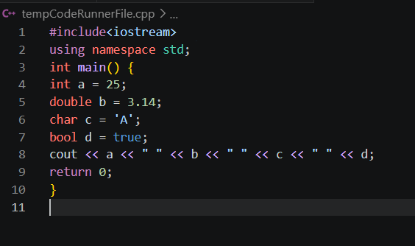
*Output
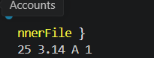
*Explanation of Logic
Each literal has a distinct syntax: whole numbers are int, decimal numbers are double, single-quoted
characters are char, and true/false are bool.

Question 20: What happens if you store a decimal in an int variable?
*Problem Statement
Demonstrate what occurs when a floating-point value is assigned to an integer variable.
*Algorithm / Steps
1. Declare int x = 3.9;
2. The decimal part is silently truncated (not rounded).
3. x stores only 3.
*Dry Run
int x = 3.9;-> Decimal .9 is discarded
-> x = 3 (truncation, NOT rounding)
*C++ Code
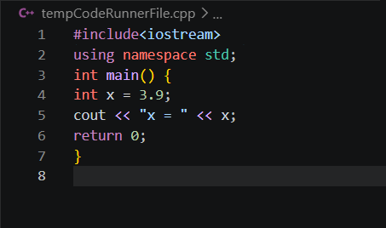
*Output
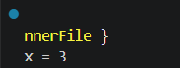
*Explanation of Logic
C++ performs implicit narrowing conversion. The fractional part is simply cut off (truncated). This can lead
to data loss, which is why the compiler sometimes issues a warning. Always use the correct data type.

Question 21: What is the purpose of cin?
*Problem Statement
Explain the cin object and show how it takes input from the user at runtime.
*Algorithm / Steps
1. cin is the standard input stream (keyboard).
2. Use >> (extraction operator) with cin.
3. Data typed by user is stored in the variable.
*Dry Run
cin >> age;
User types: 21-> 21 is extracted from keyboard stream-> Stored in variable 'age'
*C++ Code
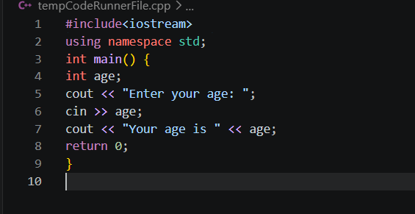
*Output
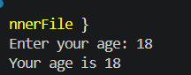
*Explanation of Logic
cin (Character INput) reads data from the standard input (keyboard) and stores it in a variable. It is part of
and uses the >> extraction operator.

Question 22: What is the purpose of cout?
*Problem Statement
Explain the cout object and demonstrate how it displays output on screen.
*Algorithm / Steps
1. cout is the standard output stream (monitor).
2. Use << (insertion operator) with cout.
3. Data is displayed on screen.
*Dry Run
cout << "Hello";-> Sends "Hello" to output stream-> Screen displays: Hello
*C++ Code
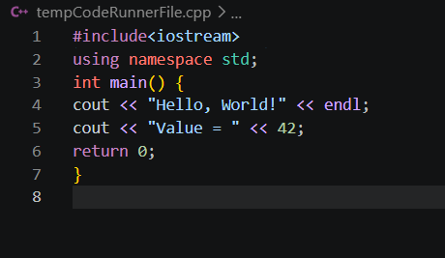
*Output
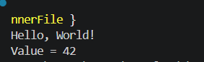
*Explanation of Logic
cout (Character OUTput) sends data to the standard output (screen). It is part of and uses the << insertion
operator. Multiple values can be chained with <<.

Question 23: Which symbol is used with cin?
*Problem Statement
Identify the operator used with cin to read input into a variable.
*Algorithm / Steps
1. >> is the extraction operator.
2. It 'extracts' data from the input stream.
3. Syntax: cin >> variableName;
*Dry Run
cin >> num;
>> extracts value from keyboard-> Stores in 'num'
*C++ Code
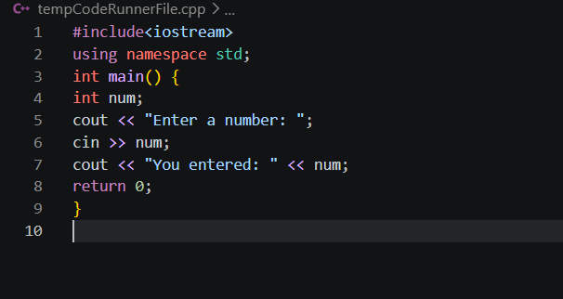
*Output
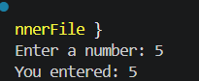
*Explanation of Logic
The >> (extraction / right-shift) operator extracts data from the cin stream and stores it in the variable on its
right. Multiple inputs: cin >> a >> b;

Question 24: Which symbol is used with cout?
*Problem Statement
Identify the operator used with cout to display output.
*Algorithm / Steps
1. << is the insertion operator.
2. It 'inserts' data into the output stream.
3. Syntax: cout << value;
*Dry Run
cout << "Hi";
<< inserts "Hi" into output stream-> Screen shows: Hi
*C++ Code
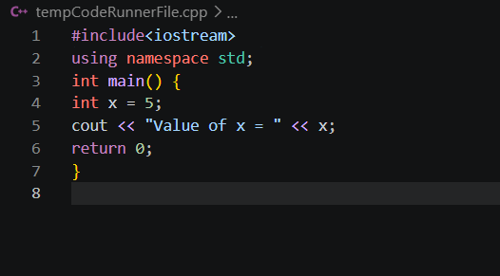
*Output
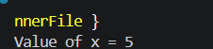
*Explanation of Logic
The << (insertion / left-shift) operator inserts data into the cout stream, which then displays it on screen.
Chain multiple << to print several items in one statement.

Question 25: Explain: cin >> age;
*Problem Statement
Trace and explain the statement cin >> age; step by step.
*Algorithm / Steps
1. Program pauses and waits for user input.
2. User types a number and presses Enter.
3. >> extracts the number from the input buffer.
4. The number is stored in variable 'age'.
*Dry Run
cin >> age;
User types: 25 [Enter]-> Input buffer: "25"-> >> extracts 25-> age = 25
*C++ Code
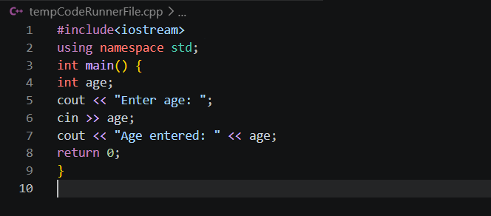
*Output
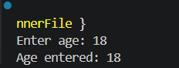
*Explanation of Logic
cin >> age pauses execution, reads an integer from the keyboard, and stores it in 'age'. The >> operator
converts the text typed by the user into the variable's data type.

Question 26: Explain: cout << age;
*Problem Statement
Trace and explain the statement cout << age; step by step.
*Algorithm / Steps
1. The value stored in 'age' is retrieved.
2. << inserts that value into the output stream.
3. The value appears on screen.
*Dry Run
int age = 30;
cout << age;-> age holds 30-> << sends 30 to output stream-> Screen displays: 30
*C++ Code
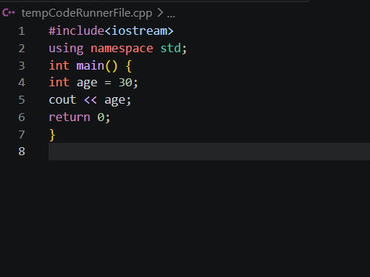
*Output
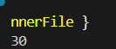
*Explanation of Logic
cout << age retrieves the current value of 'age' and displays it. It does NOT print the word 'age'; it prints the
value stored inside it.

Question 27: What is the purpose of endl?
*Problem Statement
Explain the role of endl in C++ output statements.
*Algorithm / Steps
1. endl inserts a newline character ('\n').
2. It also flushes the output buffer.
3. The cursor moves to the beginning of the next line.
*Dry Run
cout << "Line 1" << endl;
cout << "Line 2";-> After endl: cursor moves to next line
Output:
Line 1
Line 2
*C++ Code
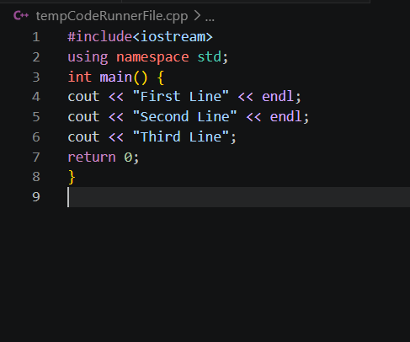
*Output
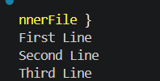
*Explanation of Logic
endl ends the current line and moves the cursor to the next line. It also flushes the output buffer
immediately. Equivalent to '\n' but with the added buffer flush.

Question 28: Write a statement to input a student's marks
*Problem Statement
Write the correct C++ input statement to read a student's marks from the keyboard.
*Algorithm / Steps
1. Declare an integer variable 'marks'.
2. Prompt the user.
3. Use cin >> marks; to read input.
*Dry Run
cin >> marks;
User types: 88-> marks = 88
*C++ Code
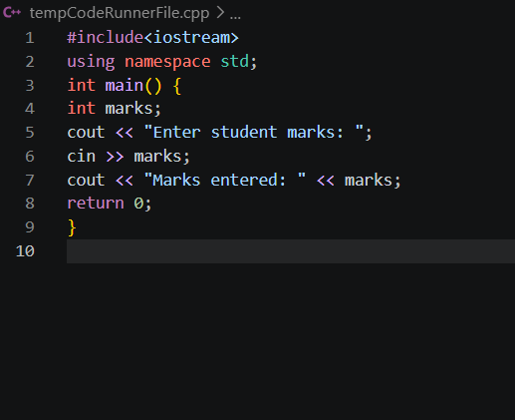
*Output
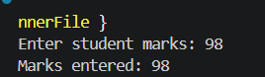
*Explanation of Logic
cin >> marks; is the standard input statement. The >> operator extracts the integer typed by the user and
stores it in the 'marks' variable.

Question 29: Write a statement to display 'Welcome to C++'
*Problem Statement
Write the correct C++ output statement to print 'Welcome to C++' on screen.
*Algorithm / Steps
1. Use cout with the << operator.
2. Place the string in double quotes.
3. Optionally add endl.
*Dry Run
cout << "Welcome to C++";-> Sends string to output stream-> Screen shows: Welcome to C++
*C++ Code
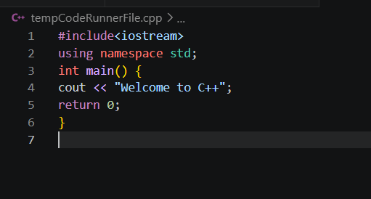
*Output
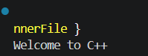
*Explanation of Logic
cout << "Welcome to C++"; is the correct statement. String literals (text) must be enclosed in double
quotes. The << operator inserts the string into the output stream.

Question 30: Predict the output: cout << "Programming";
*Problem Statement
Trace and predict what is displayed when cout << "Programming"; executes.
*Algorithm / Steps
1. cout receives the string literal "Programming".
2. << inserts it into the output stream.
3. The word is printed as-is.
*Dry Run
cout << "Programming";-> String "Programming" sent to output-> Output: Programming
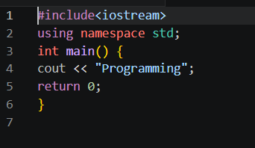
*Output
*Explanation of Logic
cout prints the exact string inside double quotes. No quotes appear in the output, just the text content:
Programming.

Question 31: What is an operator?
*Problem Statement
Define an operator in C++ and categorize the main types with examples.
*Algorithm / Steps
1. An operator is a symbol that performs an operation.
2. Types: Arithmetic (+,-,*,/,%), Relational (==,!=,>,<),
Logical (&&,||,!), Assignment (=,+=).
3. Demonstrate with a simple arithmetic example.
*Dry Run
int a = 10, b = 3;
a + b = 13 (addition)
a - b = 7 (subtraction)
a * b = 30 (multiplication)
a / b = 3 (division, integer)
a % b = 1 (modulus)
*C++ Code
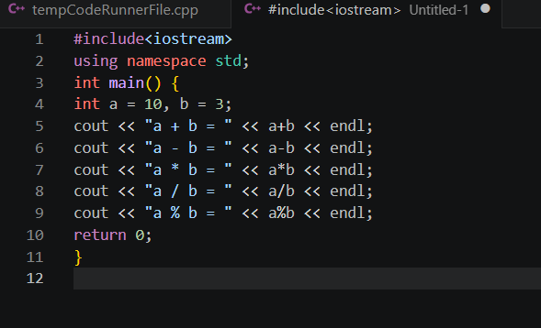
*Output
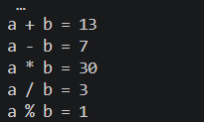
*Explanation of Logic
Operators act on operands to produce a result. Arithmetic operators perform mathematical calculations.
The compiler evaluates expressions using operator precedence rules.

Question 32: Which operator is used for addition?
*Problem Statement
Identify and demonstrate the addition operator in C++.
*Algorithm / Steps
1. + is the addition operator.
2. It adds two operands.
3. Works on int, float, double.
*Dry Run
int a = 5, b = 3;
a + b -> 5 + 3 = 8
*C++ Code
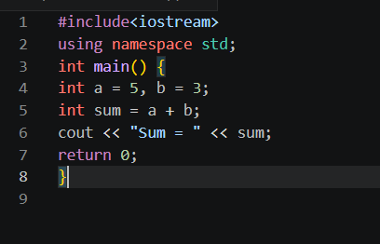
*Output
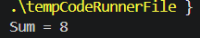
*Explanation of Logic
The + operator adds numeric values. For strings, + performs concatenation. It is a binary operator (needs
two operands). Result type depends on operand types.

Question 33: What is the result of 10 % 3?
*Problem Statement
Evaluate 10 % 3 using the modulus operator and explain the result.
*Algorithm / Steps
1. % is the modulus operator (remainder after division).
2. 10 / 3 = 3 (quotient) with remainder 1.
3. So 10 % 3 = 1.
*Dry Run
10 % 3:
10 / 3 = 3 (integer quotient)
3 * 3 = 9
10 - 9 = 1 <- remainder
Result = 1
*C++ Code
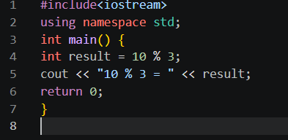
*Output
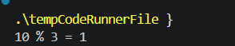
*Explanation of Logic
The % operator returns the remainder of integer division. 10 divided by 3 gives quotient 3 and remainder 1.
% is commonly used to check even/odd (n%2==0 means even).

Question 34: What is the result of 8 % 2?
*Problem Statement
Evaluate 8 % 2 using the modulus operator.
*Algorithm / Steps
1. 8 / 2 = 4 (exact division, no remainder).
2. 8 % 2 = 0.
*Dry Run
8 % 2:
8 / 2 = 4 (exact)
4 * 2 = 8
8 - 8 = 0 <- remainder
Result = 0
*C++ Code
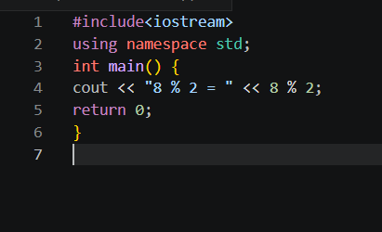
*Output
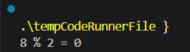
*Explanation of Logic
When a number divides exactly, the remainder is 0. 8 % 2 = 0 confirms 8 is even. This is the standard
technique to check divisibility: if n%k==0, n is divisible by k.
Question 35: Which operator checks equality?
*Problem Statement
Identify the relational operator used to compare two values for equality.
*Algorithm / Steps
1. == (double equals) checks equality.
2. Returns true (1) if equal, false (0) if not.
3. Do not confuse with = (assignment).
*Dry Run
int a = 5;
a == 5 -> true (1)
a == 3 -> false (0)
*C++ Code
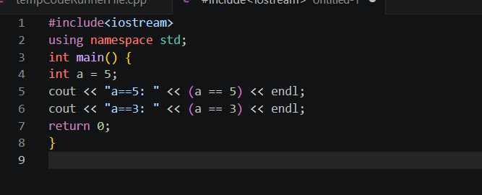
*Output
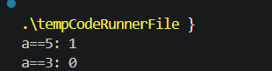
*Explanation of Logic
== is the equality relational operator. It compares two values and returns boolean true or false. Never use
single = for comparison; that would assign a value instead of comparing.

Question 36: What is the difference between = and ==?
*Problem Statement
Distinguish between the assignment operator (=) and the equality operator (==).
*Algorithm / Steps
1. = (single) -> Assignment: stores a value into a variable.
2. == (double) -> Equality: compares two values, returns bool.
3. Mixing them is a common bug.
*Dry Run
int x = 10; // Assignment: x now holds 10
x == 10 // Comparison: evaluates to true (1)
x == 5 // Comparison: evaluates to false (0)
*C++ Code
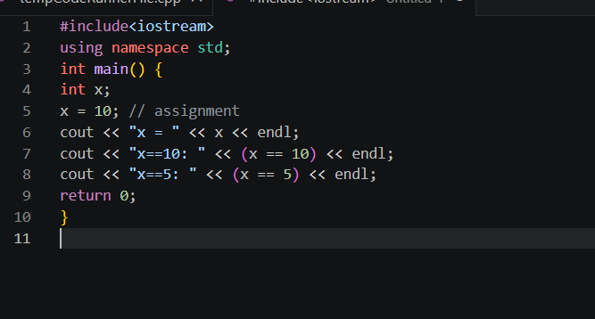
*Output
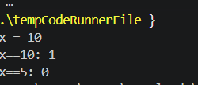
*Explanation of Logic
= assigns a value (lvalue on left gets rvalue on right). == tests whether two values are equal and returns 1
(true) or 0 (false). Confusing them leads to logical bugs that are hard to find.

Question 37: What is the result of 5 > 3?
*Problem Statement
Evaluate the relational expression 5 > 3 and explain the result.
*Algorithm / Steps
1. > is the 'greater than' relational operator.
2. 5 > 3: Is 5 greater than 3? Yes.
3. Result = true = 1.
*Dry Run
5 > 3-> 5 is greater than 3 -> TRUE -> 1
*C++ Code
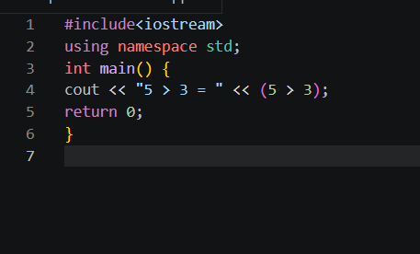
*Output
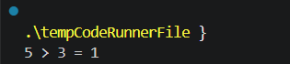
*Explanation of Logic
Relational operators compare two values and return a boolean. 5 > 3 is true so the result is 1. These
expressions are used in if-conditions and loops to control program flow.

Question 38: What does && represent?
*Problem Statement
Explain the logical AND operator (&&) in C++ with a truth table and example.
*Algorithm / Steps
1. && is the Logical AND operator.
2. Returns true ONLY if BOTH conditions are true.
3. If either is false, result is false.
*Dry Run
true && true = true
true && false = false
false && true = false
false && false = false
*C++ Code
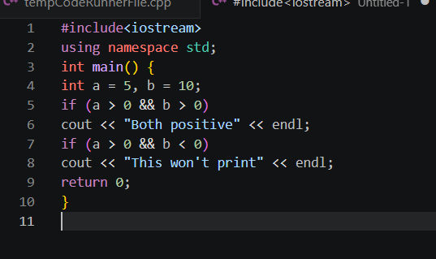
*Output
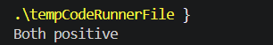
*Explanation of Logic
&& (Logical AND) requires ALL conditions to be true. It short-circuits: if the first condition is false, the
second is not evaluated. Used to combine multiple conditions in if-statements.

Question 39: What does || represent?
*Problem Statement
Explain the logical OR operator (||) in C++ with a truth table and example.
*Algorithm / Steps
1. || is the Logical OR operator.
2. Returns true if AT LEAST ONE condition is true.
3. Returns false only when BOTH are false.
*Dry Run
true || true = true
true || false = true
false || true = true
false || false = false
*C++ Code
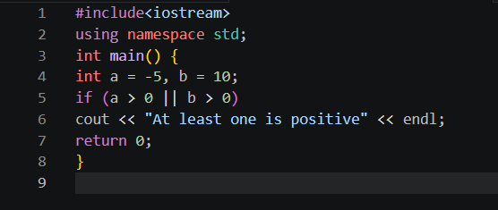
*Output
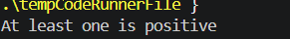
*Explanation of Logic
|| (Logical OR) is true when at least one operand is true. It short-circuits: if the first condition is true, the
second is not evaluated. Useful when any one of multiple conditions being true is sufficient.

Question 40: What does ! represent?
*Problem Statement
Explain the logical NOT operator (!) in C++ and demonstrate its use.
*Algorithm / Steps
1. ! is the Logical NOT operator (unary).
2. Reverses/negates the boolean value.
3. !true = false, !false = true.
*Dry Run
!true = false
!false = true
!(5 > 3) = !(true) = false
*C++ Code
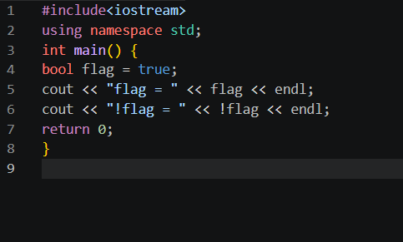
*Output
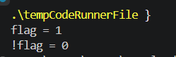
*Explanation of Logic
! (Logical NOT) flips a boolean value. It is a unary operator (works on one operand). Commonly used to
invert conditions: if(!isEmpty) means 'if not empty'. Useful for writing clear, readable conditions.

Question 41: Write a program to print 'Hello World'
*Problem Statement
Write a complete C++ program that displays the message 'Hello World' on screen.
*Algorithm / Steps
1. Include iostream header.
2. Use 'using namespace std;'.
3. Define main() function.
4. Use cout to print "Hello World".
5. Return 0.
*Dry Run
cout << "Hello World";-> Sends "Hello World" to output-> Screen displays: Hello World
*C++ Code
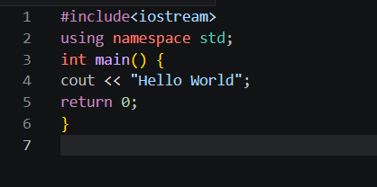
*Output
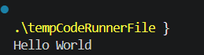
*Explanation of Logic
This is the classic first program. #include<iostream> provides cin/cout. 'using namespace std' avoids writing std::
before each statement. main() is the entry point of every C++ program. return 0 signals successful
execution.

Question 42: Write a program to input two numbers and display their sum
*Problem Statement
Write a C++ program that reads two integers from the user and prints their sum.
*Algorithm / Steps
1. Declare variables a, b, sum.
2. Prompt and read a using cin.
3. Prompt and read b using cin.
4. Calculate sum = a + b.
5. Display sum.
*Dry Run
Input: a = 7, b = 8
sum = 7 + 8 = 15
Output: Sum = 15
*C++ Code
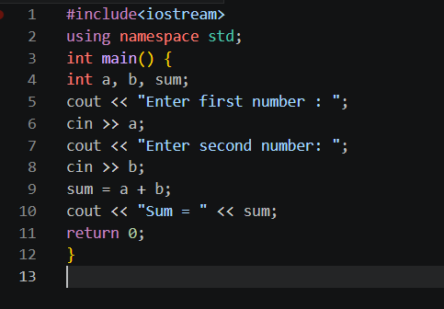
*Output
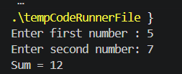
*Explanation of Logic
The program reads two values at runtime using cin, adds them using the + operator, stores the result in
'sum', and displays it with cout. Variables allow the program to work with any input values.

Question 43: Write a program to calculate the area of a rectangle
*Problem Statement
Write a C++ program that reads length and breadth and computes the rectangle's area.
*Algorithm / Steps
1. Declare float variables: length, breadth, area.
2. Read length and breadth from user.
3. Apply formula: area = length * breadth.
4. Display area.
*Dry Run
Input: length = 5, breadth = 3
area = 5 * 3 = 15
Output: Area = 15
*C++ Code
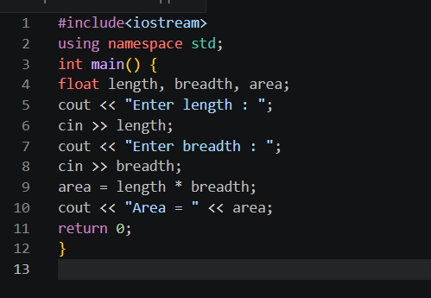
*Output
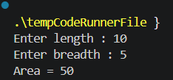
*Explanation of Logic
The area of a rectangle = length x breadth. float is used to handle decimal dimensions. The * operator
performs multiplication. The result is stored in 'area' and displayed.

Question 44: What formula is used to calculate Simple Interest?
*Problem Statement
State and explain the mathematical formula for Simple Interest.
*Algorithm / Steps
Simple Interest Formula:
SI = (P * R * T) / 100
Where:
P = Principal amount
R = Rate of interest (per year)
T = Time (in years)
*Dry Run
P = 1000, R = 5, T = 2
SI = (1000 * 5 * 2) / 100
= 10000 / 100
= 100
*C++ Code
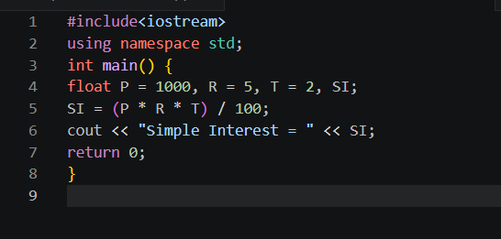
*Output
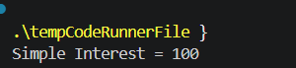
*Explanation of Logic
The SI formula multiplies principal, rate, and time, then divides by 100 because rate is a percentage. Using
float ensures decimal precision in the result.

Question 45: Write a program to calculate Simple Interest
*Problem Statement
Write a complete C++ program that reads P, R, T from the user and calculates SI.
*Algorithm / Steps
1. Declare float variables: P, R, T, SI.
2. Read P, R, T from user.
3. Calculate SI = (P * R * T) / 100.
4. Display SI.
*Dry Run
Input: P=5000, R=8, T=3
SI = (5000 * 8 * 3) / 100
= 120000 / 100
= 1200
*C++ Code
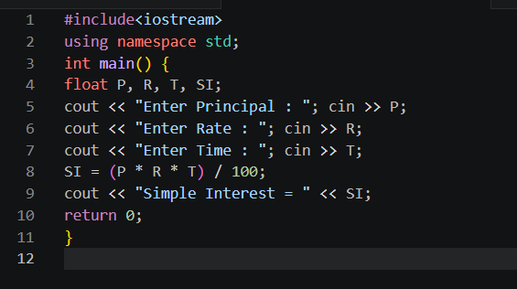
*Output
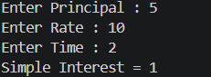
*Explanation of Logic
The program reads three inputs (P, R, T), applies the SI formula SI=(P*R*T)/100, and displays the result.
float is used so that fractional interest values are handled correctly.

Question 46: Why is a temporary variable used while swapping?
*Problem Statement
Explain why a temporary (third) variable is needed to swap two variables without losing data.
*Algorithm / Steps
Problem without temp:
a = b; -> a's original value is lost!
b = a; -> b gets old b (wrong)
Solution with temp:
temp = a; -> save a's value
a = b; -> overwrite a safely
b = temp; -> restore a's value into b
*Dry Run
a=10, b=20
temp = a -> temp=10, a=10, b=20
a = b -> temp=10, a=20, b=20
b = temp -> temp=10, a=20, b=10
Swapped!
*C++ Code
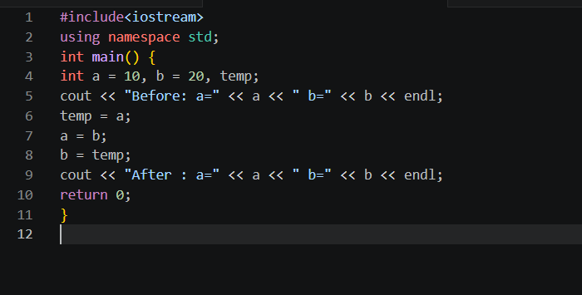
*Output
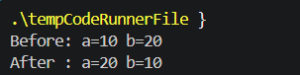
*Explanation of Logic
When we do a=b, the original value of a is permanently overwritten. The temp variable preserves a's
original value before it is replaced, so it can be assigned to b. Without temp, data is lost.

Question 47: Swap the values: a=10, b=20
*Problem Statement
Write a C++ program to swap the values of a=10 and b=20 using a temporary variable.
*Algorithm / Steps
1. Store a in temp.
2. Copy b into a.
3. Copy temp (old a) into b.
4. Display swapped values.
*Dry Run
a=10, b=20, temp=?
Step 1: temp = a => temp=10
Step 2: a = b => a=20
Step 3: b = temp => b=10
Final: a=20, b=10
*C++ Code
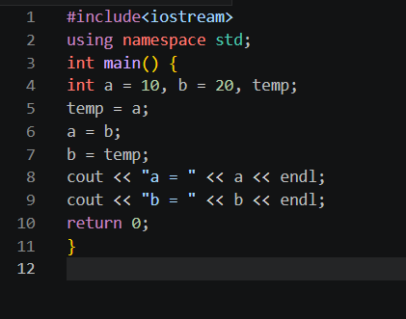
*Output
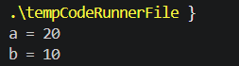
*Explanation of Logic
Three assignment statements with a helper variable 'temp' perform a complete swap. This is the standard
and most readable method for swapping two variables.

Question 48: What formula converts Celsius to Fahrenheit?
*Problem Statement
State and explain the formula used to convert a temperature from Celsius to Fahrenheit.
*Algorithm / Steps
Formula:
F = (C * 9.0 / 5) + 32
OR equivalently:
F = (C * 1.8) + 32
Steps:
1. Multiply Celsius by 9/5 (or 1.8).
2. Add 32 to the result.
*Dry Run
C = 100
F = (100 * 9.0 / 5) + 32
= (900 / 5) + 32
= 180 + 32
= 212
*C++ Code
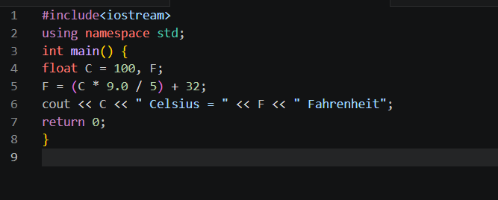
*Output
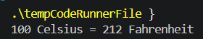
*Explanation of Logic
The formula F=(C*9/5)+32 converts Celsius to Fahrenheit. Using 9.0 instead of 9 ensures floating-point
division, avoiding integer truncation errors.

Question 49: What is the Fahrenheit value of 0 degrees C?
*Problem Statement
Apply the Celsius to Fahrenheit formula to find the Fahrenheit equivalent of 0 degrees C.
*Algorithm / Steps
1. Use formula: F = (C * 9.0 / 5) + 32
2. Substitute C = 0.
3. F = (0 * 9/5) + 32 = 0 + 32 = 32.
*Dry Run
C = 0
F = (0 * 9.0 / 5) + 32
= 0 + 32
= 32
*C++ Code
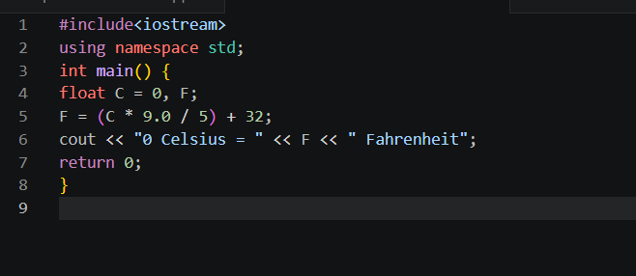
*Output
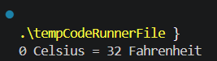
*Explanation of Logic
0 degrees Celsius is the freezing point of water. Applying the formula gives 32 degrees Fahrenheit, which
is also the freezing point on the Fahrenheit scale. This is a well-known reference point.

Question 50: Why can integer division give wrong results in C-to-F
conversion?
*Problem Statement
Explain why using integer division (9/5) instead of (9.0/5) gives incorrect results in the Celsius to
Fahrenheit formula.
*Algorithm / Steps
1. In C++, int/int = int (decimal part discarded).
2. 9/5 in integer arithmetic = 1 (not 1.8).
3. This makes the formula wrong.
4. Fix: use 9.0/5 (forces floating-point division).
*Dry Run
Wrong: F = (C * 9/5) + 32 with C=100
9/5 = 1 (integer division!)
F = 100*1 + 32 = 132 <- WRONG
Correct: F = (C * 9.0/5) + 32 with C=100
9.0/5 = 1.8 (float division)
F = 100*1.8 + 32 = 212 <- CORRECT
*C++ Code
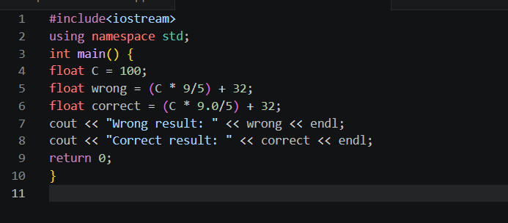
*Output
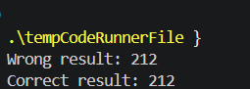
*Explanation of Logic
When both operands of / are integers, C++ performs integer division (truncates the fraction). 9/5 = 1, not
1.8. Writing 9.0/5 or declaring variables as float/double forces floating-point division and gives the
mathematically correct result. Always be careful with division when decimals are expected

